DR. AMBEDKAR COLLEGE, DEEKSHABHOOMI, NAGPUR
DEPARTMENT OF LAW
Academic Session - 2022-2023

NAME OF THE PROGRAMME: | Essay competition on the topic “Mob lynching in India- A Legal solution”.
NAME OF THE PROGRAMME CO-ORDINATOR: | Prof. Dr. Sandhya Kalamdhad
DATE AND DAY: | 29th April 2023
TOTAL NUMBER OF PARTICIPANTS: | 07- 3 Girls and 4 Boys
VENUE: | Online submission at email id crilawcc2021@gmail.com

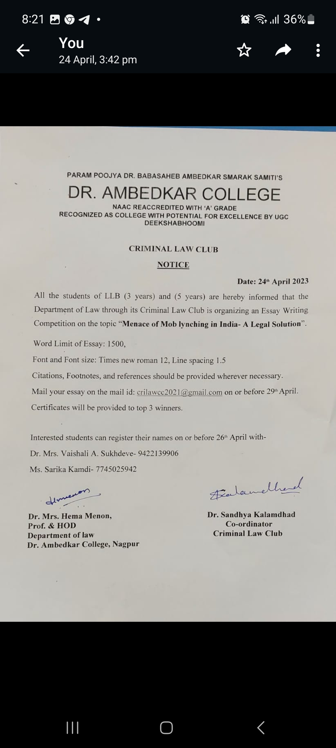
Department of Law through the Criminal Law Club organized an Essay competition on the topic “Mob lynching in India- A Legal solution” for all the students of LLB (3 YRS) and LLB (5 YRS) on 29th April 2023. This was the date of submission of online essays on the official email id of Criminal Law Club. Total 7 essays were received which were send to judges for valuation. The criteria for judgement included various factors like content, relevance to the theme, clarity of thoughts, unity, and consistency and grammar and mechanics. Adv. Abhay K. Sukhdeve and Adv. Priyanka Mardikar judged the same based on given parameters. Accordingly, Mr. Tathagat Thakur was declared as the First winner, Mr. Saroj Lanjekar secured the second position and Ms. Sharanya Nagrare/ Parth Nakade secured the third place in said essay writing competition. All the winners and participants were congratulated by the Head of the Department, Prof. Dr. H.V. Menon and the co-ordinator of Criminal law Club, Dr. Sandhya Kalamdhad. Dr. Vaishali A. Sukhdeve and Ms. Sarika Kamdi, member of the club contributed in the organization of the said competition.
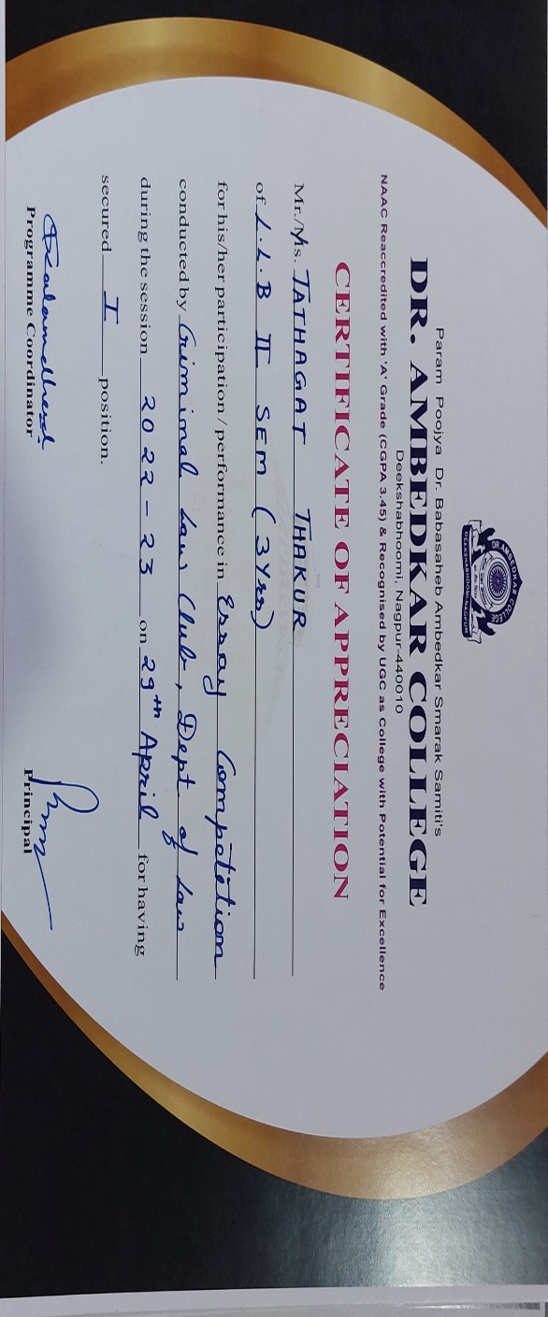
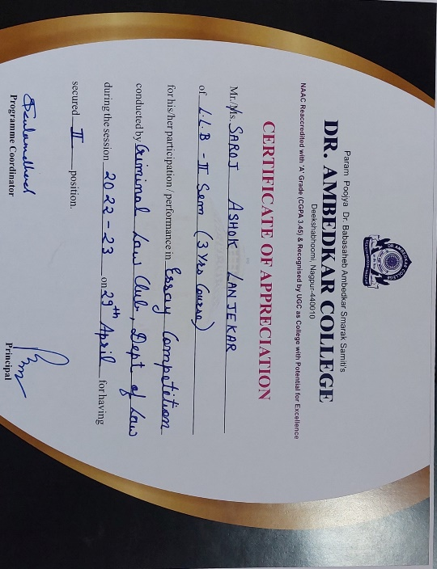 | 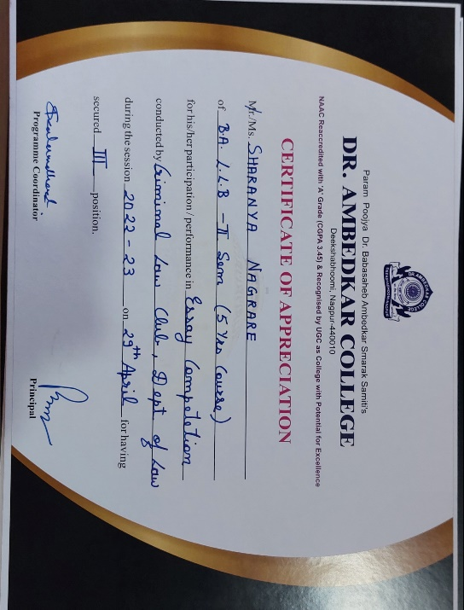

IMAGES OF ESSAYS RECEIVED ON THE EMAIL ID

